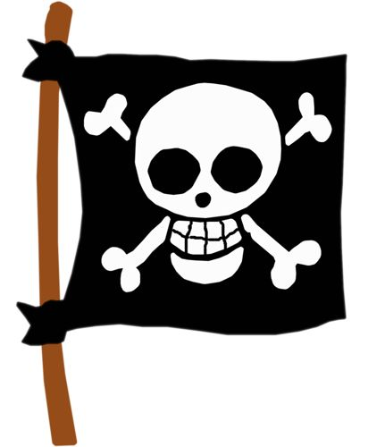
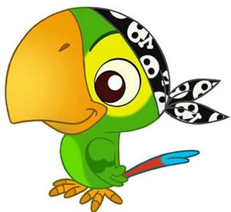
Nursery Home Learning
Week Beginning Monday 27th April

Pirate Week!

Pirate themed stories
Start the week with a pirate story. Don’t worry if you don’t have any of these at home. There are plenty of pirate stories online to watch or listen to. There are some links below which will take you to these.
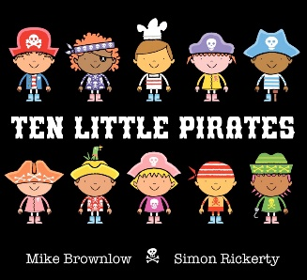  https://www.youtube.com/watch?v=VLpC0rUSB18 | 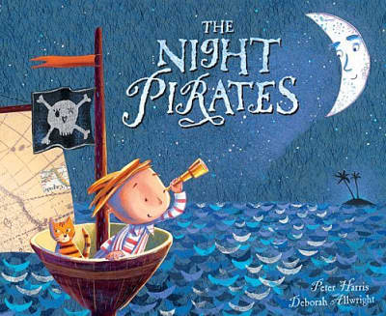https://www.youtube.com/watch?v=mdWxBn-xvrQ | 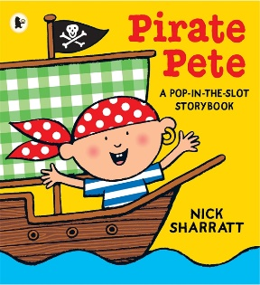https://www.youtube.com/watch?v=quNt9nFYGlU
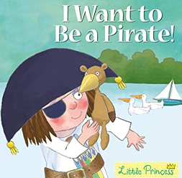https://www.youtube.com/watch?v=e__r4f1oXjE | 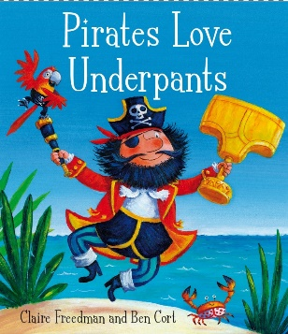  https://www.youtube.com/watch?v=Vd8_Y1bEzA8 | 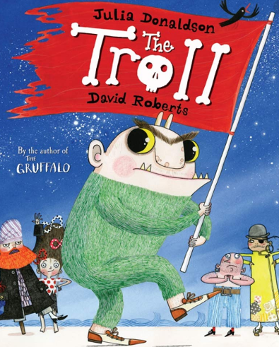https://www.youtube.com/watch?v=oZ1Q_f7JJ8E
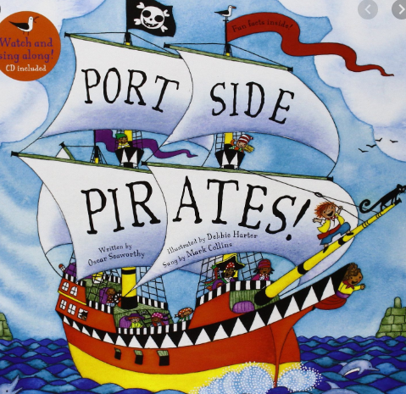https://www.youtube.com/watch?v=_qAngsMJD3I | 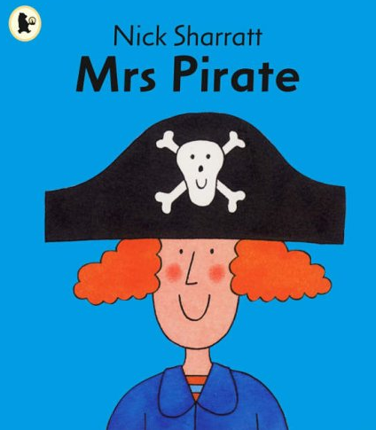https://www.youtube.com/watch?v=De7WkgzOVEI | 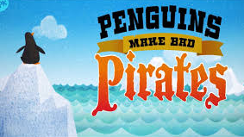  https://www.youtube.com/watch?v=usMEVqz4CrU

Get moving
- Just Dance Kids 2014 A Pirate You Shall Be
https://www.youtube.com/watch?v=oe_HDfdmnaM

- Join the Swashbuckle Pirate Party and show us some of your pirate dance moves on tapestry.
https://www.youtube.com/watch?v=vRNezeciOuo

- COSMIC KIDS pirate yoga
https://www.youtube.com/watch?v=T_0P5grVoyg

Maths
Use the ‘White Rose’ website:
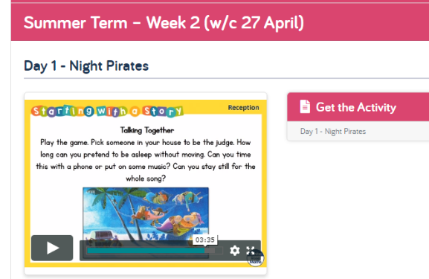
https://whiterosemaths.com/homelearning/early-years/
There is a home learning section for Early Years. If you find the section for this week, all of the activities are based around the books The Night Pirates and Troll.

Each day there are different activity ideas which can all be done without the books. Each day begins with a 5-minute video to watch. The video starts with the ‘days of the week’ song which the children should know!

Treasure Hunt
- A pirate loves treasure! Set up your own treasure hunt around your house and garden. Of course every hunt will need some clues. What do your family treasure most?

- Hide the treasure in a new place. Give directions to a grown up to help them find the treasure. Can you use any of these words: forwards, backwards, higher, lower, inside, around, through.

Floating and sinking
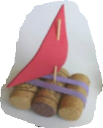
- Walk the Plank! In the book ‘Troll’, the Pirates make Troll walk the plank before they find out he can cook! What can you make walk the plank? Will it float or will it sink when it hits the water?

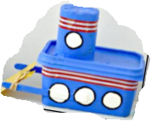
- Make your own pirate ship and test it. Think carefully about the materials you will use. You may know by now after learning about floating and sinking which materials will be best to use.

Mark making
- Design a treasure map. This could be done after you have found the treasure using the clues. Can you retrace your steps and draw this on a map in order to find the treasure next time?

- Use this link https://www.youtube.com/watch?v=De7WkgzOVEI to listen to the story of Mrs Pirate. Record what she got from the shops or write her a new list for her next shopping trip. (Remember that this does not need to look like full words. Items can be recorded as pictures or single letters if children know any. It is more important that they can tell you what they have recorded.)

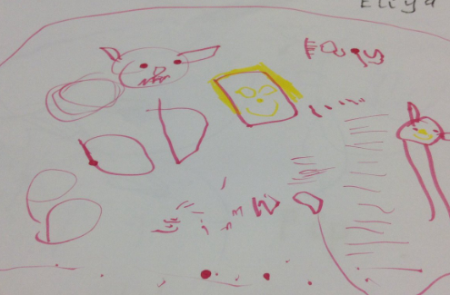
- Design a pirate hat and eyepatch – use the attached template or draw your own

- Design a pirate flag for your ship – use the attached template or draw your own

Phonics
- Letters and Sounds website phase 1 Listening games:
http://www.letters-and-sounds.com/phase-1.html

- Use the 30-day free trial at Reading Eggs to practise listening games and phonics / letters games:
https://readingeggs.co.uk/

Remember these are all just ideas, please do not feel like you have to do all of them.
Keep reading lots of books, singing songs and nursery rhymes and encouraging as much mark making with pens, pencils, paint, chalks and crayons as possible.
Keep in mind that with young children, it’s all about the process, not the product. It doesn’t really matter what the finished result looks like!
Most importantly… Have a fun week!

