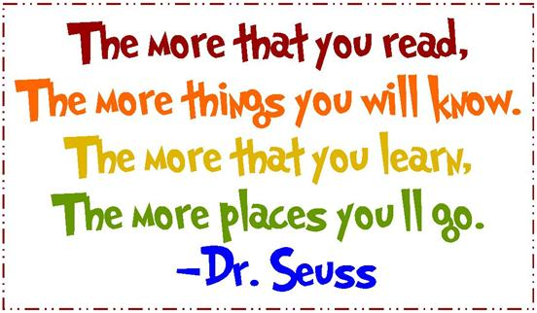
A list of suggested websites and resources for home learning in reading

Daily reading
A key area for all year groups is daily reading. In order to ensure children have access to a wide range of books that interest and engage them, you could share the following websites and ideas:

Oxford Owl free book library – https://www.oxfordowl.co.uk/for-home/find-a-book/library-page/
Parents simply have to register and they gain access to hundreds of books online (including scheme books – ORT, Hero Academy, Fireflies, Project X etc). These books are all linked to stage so will provide excellent reading material. Also by registering, parents will gain access to ideas to use at home for phonics and maths.

CBeebies story time app – The app is appropriate for younger children (EYFS and KS1) is free and it provides a whole library of interactive stories that involve the children (e.g. they have to swipe and move the jungle leaves so that the explorer can find his way through the jungle). The children have the option whether the story is read to them (and they can follow along with the text) or to have text only so that they do the reading.

CBeebies bedtime stories - https://www.bbc.co.uk/iplayer/episodes/b00jdlm2/cbeebies-bedtime-stories

Jackanory Junior - https://www.bbc.co.uk/programmes/b007t9wg
Children can use either the clips or the episodes and they can sit back and enjoy a well-read story. The series uses some great books by quality authors and some great story tellers. A brilliant way to make sure children are still getting that diet of quality texts, story language and creative thinking.

Worldbookday.com story time online - https://www.worldbookday.com/storytime-online/
As part of World Book Day this year the official website has given access to a large number of stories by well-known authors. A great way to access good quality literature.

Free books read to children on Storyline Online - https://www.storylineonline.net/

