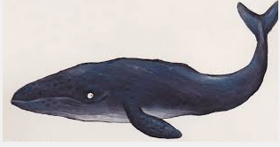
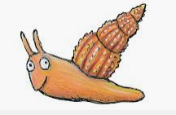
Nursery Home Learning
Week Beginning Monday 1st June

This week’s activities and ideas are based around the book
“The Snail and the Whale” By Julia Donaldson.
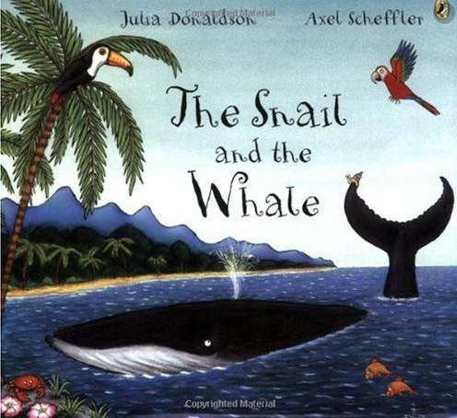
https://www.bbc.co.uk/iplayer/episode/m000cslw/the-snail-and-the-whale

Maths
‘The Snail and the Whale’ is also the topic for this week on the ‘White Rose’ website:

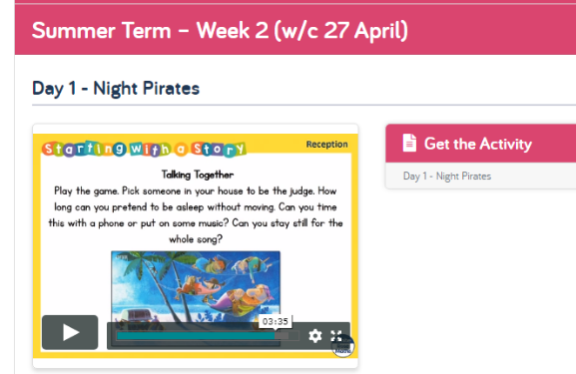
https://whiterosemaths.com/homelearning/early-years/
Go to the home learning section for Early Years and here you will find the section for this week based on ‘The Snail and the Whale’.
Each day there are different activity ideas which can all be done without the books.

Some other snail themed stories

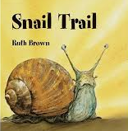https://www.youtube.com/watch?v=XsCgl6DobN4 | 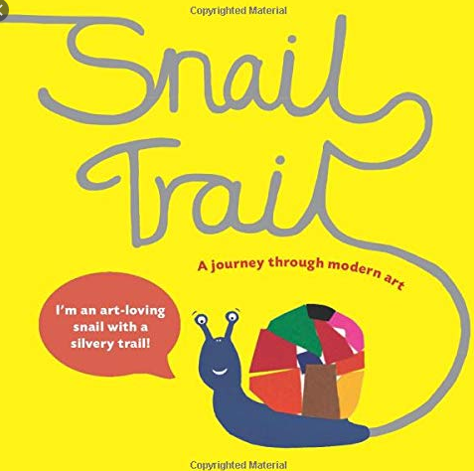https://www.youtube.com/watch?v=UkcFz7AEBAY
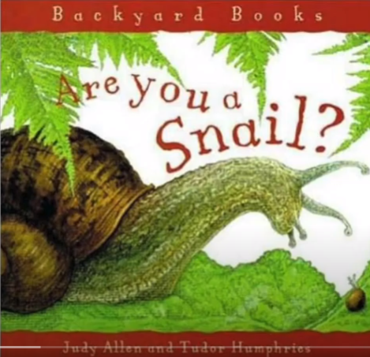https://www.youtube.com/watch?v=_H5PiUuAPv4 | 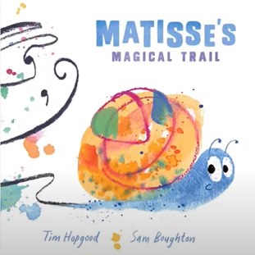  https://www.youtube.com/watch?v=S4w4Z9lMixM

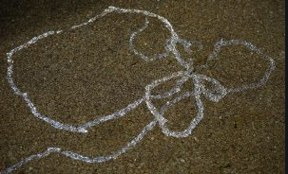
Mark making
Look for snail trails in your garden or local area and try to copy these. How many different ways can you make a snail trail? With paint, chalk, water on the fence, in flour using your finger, in the mud using a stick?

Can you include any of these patterns in your snail trail?
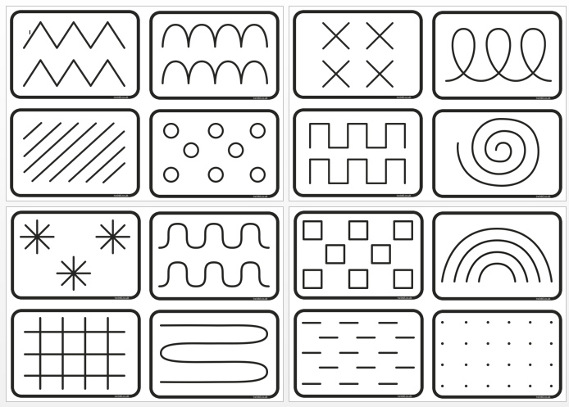
Water Experiments
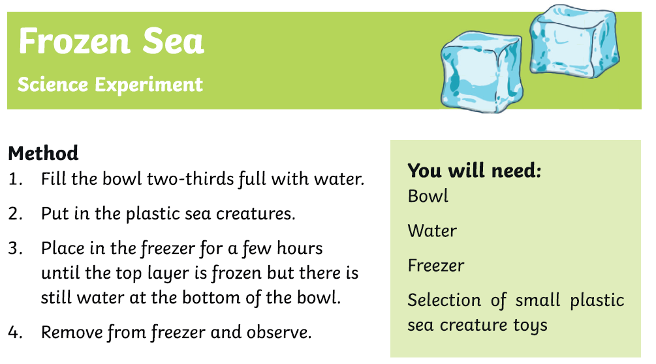

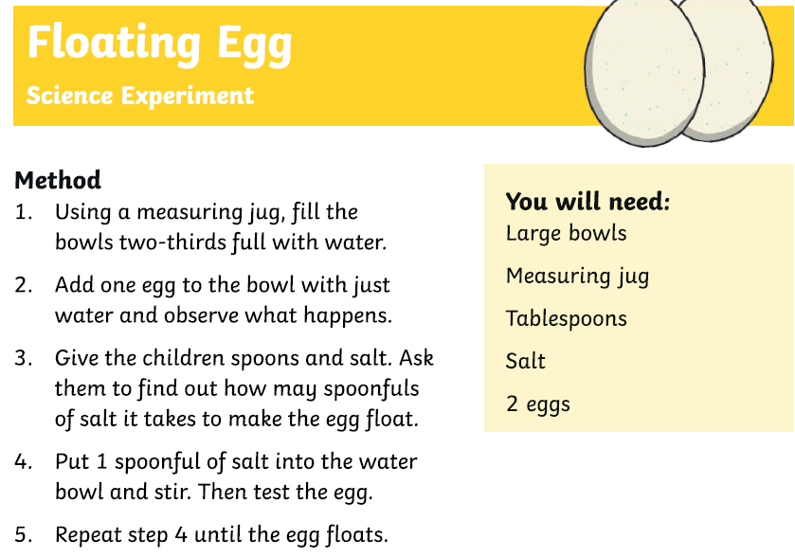

Exercise time
- Andy’s Wild Workout
https://www.bbc.co.uk/iplayer/episode/p06tmn51/andys-wild-workouts-series-1-1-under-the-sea

- Cosmic Yoga – Squish the Fish
https://www.youtube.com/watch?v=LhYtcadR9nw

- Deep Sea Core Strength
https://www.youtube.com/watch?v=pi6Sg4dKgZ0

Singing
Snail Song Lyrics :

Two little eyes, one and two.
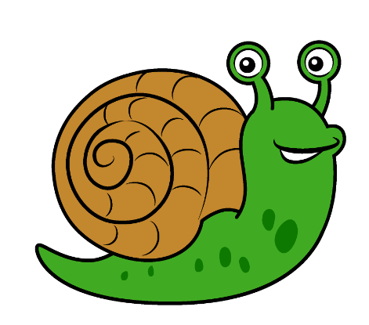
One pretty shell.
Nice to meet you.
He has no legs, just a tail.
It’s a snail, it’s a snail, it’s a snail.

Snail, snail crawling on my knee.
Snail, snail he likes me.
Snail, snail crawling on my head.
Snail, snail time to go to bed.

Snail snack ideas
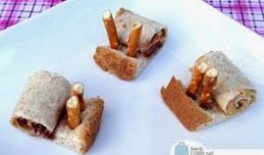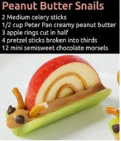
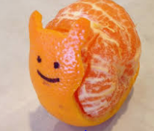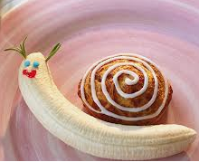

Crafts
- Use some recycling materials to create your own whale
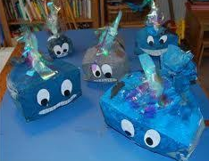
- Paint some rocks to look like a snail shell

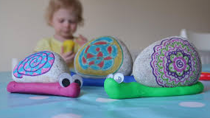

- Create a pretty shell for a snail’s home
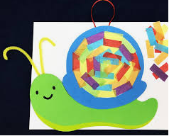

- Make a snail finger puppet
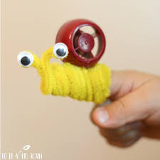
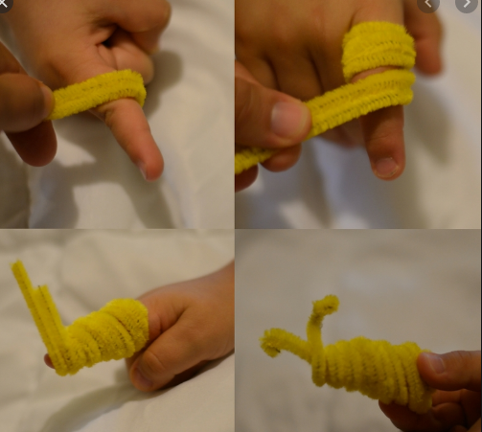

Remember these are all just ideas, please do not feel like you have to do all of them.
Keep reading lots of books, singing songs and nursery rhymes and encouraging as much mark making with pens, pencils, paint, chalks and crayons as possible.
Keep in mind that with young children, it’s all about the process, not the product. It doesn’t really matter what the finished result looks like!
Most importantly… Have a fun week!

