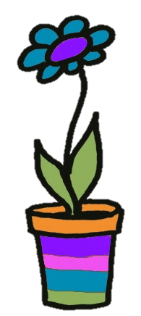 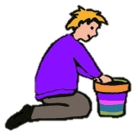

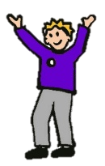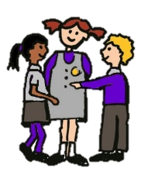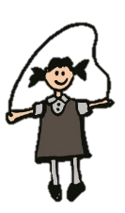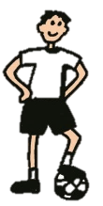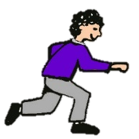

‘**Together we grow’**

**Emmaville Primary School**

**Art Policy**

**Art Co-ordinator: Ella Kenyon**

**Rationale**

Emmaville Primary School believes that Art makes a significant contribution to pupils’ education. Art encourages children to express their feelings and ideas, both as a means of self-expression and to communicate to others. Art education has also been shown to strengthen problem-solving and critical-thinking skills. The experience of making decisions and choices in the course of creating art carries over into other parts of life and other areas of learning. Art can be incredibly powerful and a remarkable way of depicting culture from all over the world, encouraging children to appreciate and celebrate cultural diversities. It is a valuable way in which children can gain insight and understanding of significant past events and traditions. Emmaville’s Art Curriculum is built on National Curriculum coverage and throughout their time at Emmaville, pupils will gain an appreciation for influential artists and their work. As well as this, pupils will also use different mediums and refine their art skills and techniques.

**Aims and Objectives - Intent**

* To inspire confidence, value and pleasure in art.
* For all pupils to have access to a varied range of high quality art experiences.
* For all pupils to be able to draw confidently and adventurously from observation, memory and imagination.
* For all pupils to explore and invent marks, develop and deconstruct ideas and communicate through purposeful drawing in 2D, 3D or digital media.
* To support all pupils to be independent, innovative and original when they develop their creativity.
* For pupils to be able to select and use materials, processes and techniques skilfully and inventively.
* For all pupils to have the ability to use visual language skilfully and convincingly (for example, line, shape, pattern, colour, texture, form) to express emotions, interpret observations and convey insights.
* For all pupils to show value to the contribution made by artists, craft workers and designers. As well as to be able to respond critically and imaginatively to ideas, images and objects.
* To give pupils the opportunity and time to reflect on, analyse and critically evaluate their own work art and artistic process as well as that of their peers.

**Approaches to learning - Implementation**

At Emmaville, teachers provide balance in teaching approaches, and the planned sequence of work throughout the school encourages pupils to use prior knowledge and skills when approaching new work. Art is linked to the history and geography curriculum, so cross curricular links are made are put into relevant context for the pupils.

We want the children to acquire the following key ideas:

* Understand how ideas develop through an artistic process.
* Develop a skill set so that ideas may be communicated.
* Learn from both the artistic process and techniques of great artists throughout history.

Pupils are given the opportunity to observe the work of a range of artists, experience different artistic techniques and learn about the work of a range of artists, artisans and designers. Pupils work independently, in mixed ability pairs and groups; allowing all children access to the curriculum.

A variety of teaching methods best suited to activities and interests of the pupils will be used. These will include:

* Images of works of art;
* Use of artefacts and visual inspiration;
* Presentation by teacher;
* Question and answer;
* Discussion and feedback;
* Each one teach one cards and other active learning methods to learn about the significance of the art work or artist;
* Educational visits to art galleries, museums and inspiring sites;

**Emmaville’s approach to learning will, provide opportunities for all children to develop as artists with skills that transfer across the curriculum.**

**Early Years Art Curriculum - Implementation**

In the Early Years Foundation Stage children begin to learn that as they grow up they are increasingly able to do more things for themselves independently. We support pupils emerging knowledge and understanding to explore crucial early art skills. The activities that we provide for the children in the early years, address a number of key artistic concepts. The activities are presented through a cross-curricular approach that aims to develop children’s learning across a range of key learning areas. Children have the opportunity to participate in adult led activities as well as child initiated art activities. The children are introduced to exploring and experimenting, using simple tools and manipulating materials. In addition to this, children in EYFS will also learn about a few artists and be supported to use the same techniques of the artist.

Art exploration in the early years include:

* Exploring what happens when colours are mixed.
* Experimenting to create different textures.
* Understanding that different media can be combined to create new effects.
* Manipulating materials to achieve a planned effect.
* Constructing with a purpose in mind, using a variety of resources.
* Using simple tools and techniques competently and appropriately to shape, assemble and join materials.

**Key Stage 1 and Key Stage 2 Art Curriculum - Implementation**

The art curriculum has been developed in line with the National Curriculum and following ideas from Chris Quigley’s Essential Curriculum and Art Curriculum Companion.

The curriculum design is based on evidence from cognitive science and is underpinned by three main principles:

* Learning is most effective when there is spaced repetition, the children will have opportunities to acquire art skills and to build upon these skills over a period of time.
* Interleaving helps pupils to discriminate between topics and aids long-term retention.
* Retrieval of previously learned skills is frequent and regular.

The content of the curriculum is subject specific but we make intra-curricular links to strengthen schema.

The art curriculum is divided into three strands that run across each key stage. These concepts are:

* Develop ideas  
  Developing ideas through an artistic process.
* Master techniques   
  Developing a skill set so that ideas may be communicated.
* Take inspiration from the greats

Learning from both the artistic process and techniques of great artists throughout history.

Each concept has its own skill set which helps to strengthen the curriculum. The following techniques are taught throughout KS1 & KS2: drawing, painting, collage, sculpture, textiles and digital media. The art scheme of work has been created to help the pupils to develop a breadth of skills and revisit these skills, so by the end of KS2 they can master techniques and skills.

Each year group has been assigned specific artists to study. The identified artists link to the year group History and Geography based topics. This ensures that by the time pupils get to the end of KS2 they have studied a diverse range of artists from all around the world and from different periods. The artists are a mix of painters, drawers, sculptors, digital media artists and textile artists.

**Assessment - Impact**

The way in which we have designed the art curriculum is to help the pupils to meet the attainment goals, known as milestones. As learning is a change to long-term memory, it is impossible to see impact in the short term and we believe that sustained mastery takes time. The milestones describe attainment at the end of a two-year period. The knowledge categories and proof of progress tasks help the pupils to meet these goals and we compare pupil’s work over time assessing the impact.

Milestone 1 – at the end of Key Stage 1

Milestone 2 – at the end of Lower Key Stage 2

Milestone 3 – at the end of Upper Key Stage 2

**The Role of the Co-ordinator**

* To take the lead in curriculum development in consultation with the headteacher, staff and governors;
* To monitor the teaching of art in the school, ensuring that there is sufficient coverage and progress in the subject;
* To lead curriculum meetings;
* To attend art network meetings and relevant courses;
* To support staff by providing information on training and develop members of staff’s confidence teaching and assessing art.
* To ensure that there are appropriate resources to support the art curriculum.

Date policy produced: February 2020

Review Date: July 2022