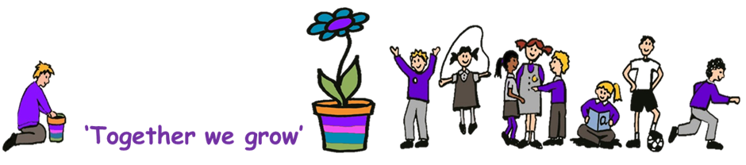

Emmaville Primary School Oral Health Policy

Oral health is an important part of general health and well-being. Good oral health enables individuals to communicate effectively, to eat and enjoy a variety of foods, and is important in overall quality of life, self-esteem and social confidence. Oral diseases are largely preventable. Pain, discomfort, sleepless nights, limitation in eating function leading to poor nutrition, and time off school due to dental problems are all common impacts of oral diseases.
The government framework states that early years providers must promote good oral health of children who attend their setting.
Oral health is important, even with baby teeth. This is because children’s teeth:
- help them to bite and chew
- support speech and language development
- help them feel confident when they smile
- baby teeth make space for and help to guide adult teeth
Good oral health also keeps children free from toothache, infection and swollen gums. We promote good oral health by linking it to other key topics, like self-care, healthy eating, and physical development as part of the national curriculum.
There are a number of ways parents and carers can promote good oral health at home this is by brushing twice daily with a fluoride toothpaste, regular visits to the dentist and reducing sugar frequency within the diet.
Our school’s Oral Health Champion is Nicola Johnson.

An Oral Health Promoter from South Tyneside and Sunderland NHS Foundation Trust has been allocated to our school to work with the staff to encourage good oral health routines.

We only offer milk and water to drink at snack times

Use of water bottles and drinking fountains are encouraged during the school. No juice/cordial is given at snack times and is not allowed in water bottles. We do not allow fizzy drinks and energy drinks in school.

We only offer healthy snacks to eat

Children are offered fruit as part of fruit in schools’ scheme. No dried fruit should be given routinely as a snack, although on occasion dried fruit may be provided by the free fruit scheme after school holiday periods.

School Meals
Gateshead School Meals Service provide our school meals. The menu always has a varied choice of healthy options including a vegetarian dish. Children with special dietary needs are catered for by prior arrangement. Children are encouraged to make healthy choices of food and to try different things they have not had before, especially vegetables.

Packed Lunches

Children are allowed to bring a packed lunch. Children are not allowed to bring fizzy drinks as part of their packed lunch. Children are not allowed to bring sweets as part of their packed lunch but are encouraged to bring a healthy, well balanced meal. If we feel a child is not eating a nutritious packed lunch this will be discussed with parents.

Dental Visits

It is very important that children have regular dental examinations starting as young an age as possible. As a school, we will ask and record upon admission who is your child’s regular Dentist. Visit or phone the practice of your choice and ask if they are happy to see your child under the NHS. You are not obliged to stay at the same dentist and can change practice if you want to, however it is getting increasingly difficult to find an NHS dentist.

To locate an NHS dentist who is accepting new and/or emergency patients please access https://www.nhs.uk/service-search/find-a-dentist or dial 111 for dental emergency and out of hours care.

Dental emergencies

If a child is in any discomfort (complaining of toothache etc) school personnel would contact the parent to inform them, and to suggest that a visit to the dentist may be required.

Date: November 2023
Review Date: November 2025

