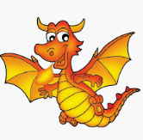
Nursery Home Learning
Week Beginning Monday 15th June

This week’s activities and ideas are based around the book “Princess Mirror-Belle and the Dragon Pox” By Julia Donaldson.
Perhaps start the week with a dragon story or two? If you haven’t got any dragon books in your collection at home there are lots online that you can watch. Here are some of our suggestions:
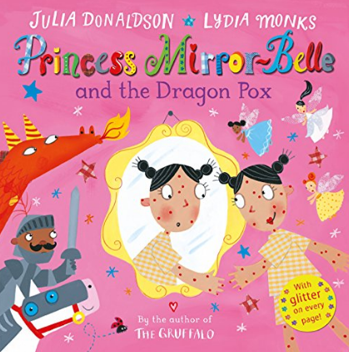  https://www.youtube.com/watch?v=LAFaJfcqqt4 | 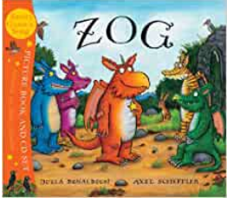https://www.youtube.com/watch?v=qZqFqI0MAfU
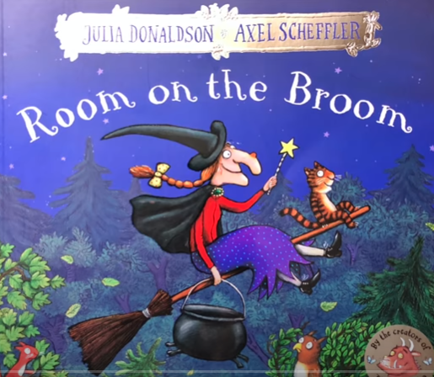https://www.youtube.com/watch?v=XRany_OScms | 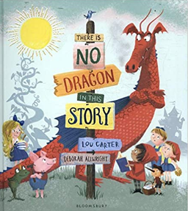https://www.youtube.com/watch?v=3PeoWeEO4kA

How to make a dragon egg
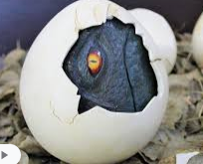
This would be an exciting introduction to the week, if your children found their own dragon egg and discovered what was inside!
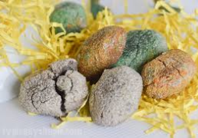

https://www.google.com/search?bih=657&biw=1366&rlz=1C1GGRV_enGB776GB776&hl=en-US&ei=4EriXuKKEtHpxgOpkInQAw&q=how+to+make+a+dinosauregg+with+flour&oq=how+to+make+a+dinosauregg+with+flour&gs_lcp=CgZwc3ktYWIQAzIECCEQCjoECAAQR1DVOliaSWCHTGgAcAJ4AIABZ4gBzgSSAQM3LjGYAQCgAQGqAQdnd3Mtd2l6&sclient=psy-ab&ved=0ahUKEwji-pOYh_rpAhXRtHEKHSlIAjoQ4dUDCAw&uact=5#kpvalbx=_60riXpjZDpSh1fAP26y-sAQ53

Maths
“Princess Mirror-Belle and the Dragon Pox” is the theme for this week on the ‘White Rose’ website:
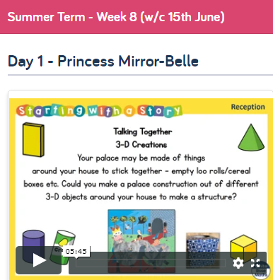
https://whiterosemaths.com/homelearning/early-years/
Go to the home learning section for Early Years and here you will find the section for this week based on ‘Princess Mirror-Belle and the Dragon Pox.

Each day begins with a 5-minute video to watch. There are different activity ideas which can all be done without the book. The video starts with the ‘days of the week’ song which the children should know!

Music
Gateshead Music Service are posting a free 30 minute music session for Early Years Children on Facebook.
It is 'Live' on Thursdays at 10.30am. The sessions can be accessed during or after the live session.
You can access them by logging on to Facebook and searching for 'Gateshead Music Service'. You can find all the sessions in the 'Videos' section or in the 'Posts'. There are 5 sessions available at the moment!
I hope your children enjoy singing, clapping, dancing and playing along to the sessions!

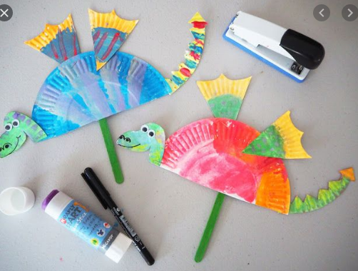
Cut and Stick

Paper plate dragon

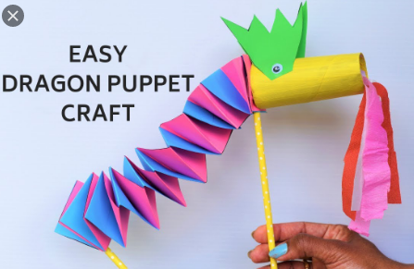

Dragon puppet

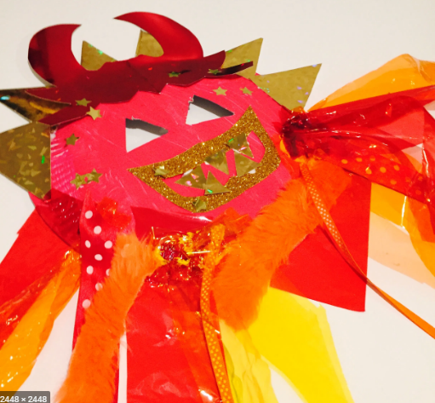

Dragon mask

Exercise time
- Practice these breathing techniques and learn to breathe fire like a dragon!
https://www.cosmickids.com/five-fun-breathing-practices-for-kids/

- School Sports Partnership ‘Rununite’
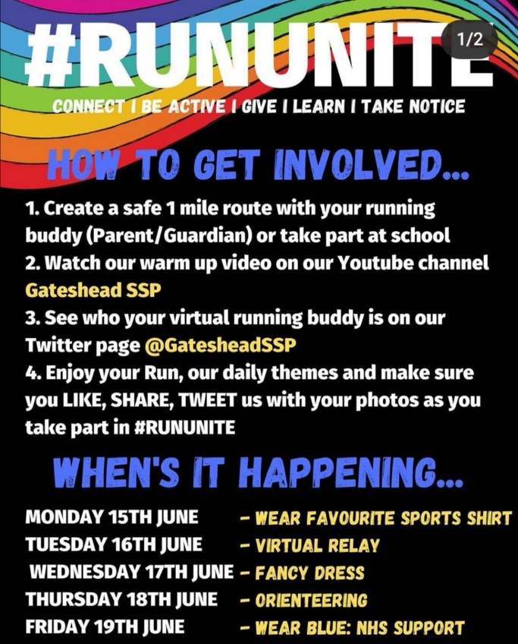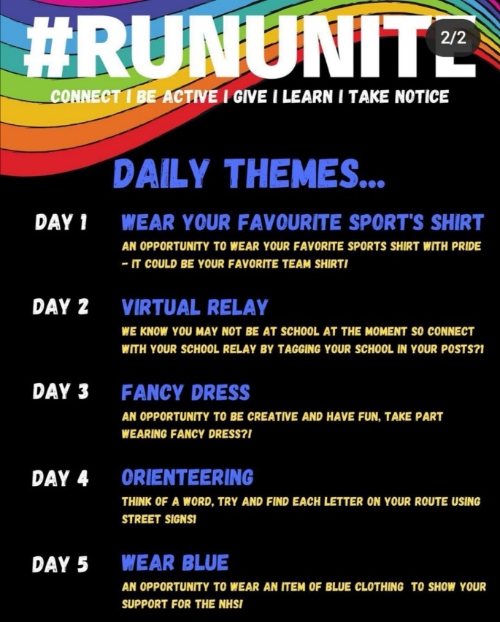

- Athletics challenges
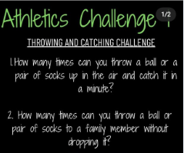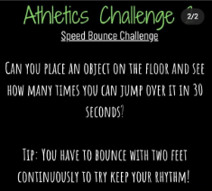

Remember these are all just ideas, please do not feel like you have to do all of them.
Keep reading lots of books, singing songs and nursery rhymes and encouraging as much mark making with pens, pencils, paint, chalks and crayons as possible.
Keep in mind that with young children, it’s all about the process, not the product. It doesn’t really matter what the finished result looks like!
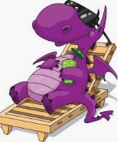
Most importantly… Have a fun week!

