Nursery Home Learning
Week Beginning Monday 29th June
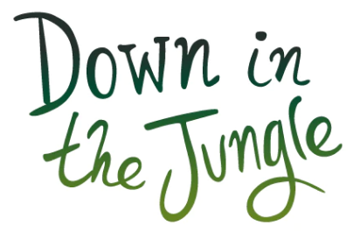
Perhaps start the week with a jungle themed story? If you haven’t got any jungle books in your collection at home there are lots online that you can watch. Here are some of our suggestions:
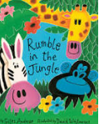  https://www.youtube.com/watch?v=D2-O1LkCzpM | 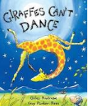  https://www.youtube.com/watch?v=Zzb5Acl-n70
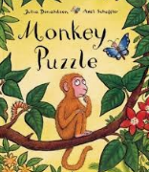https://www.youtube.com/watch?v=iIn8sjN1pgw | 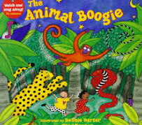  https://www.youtube.com/watch?v=25_u1GzruQM

Art week
Monday 29th June is the start of Children's Art Week. We thought it would be nice if all children across school could incorporate some art based activities into their Home Learning to celebrate the week.
Here are some jungle themed art ideas:
- Jungle animal handprints
- Cut a paper plate into a spiral for a hanging snake
- Use tubes to make tall giraffes
- Cut and stick small pieces of paper to make a colourful lizard
- Blow black paint with a straw to create zebra stripes
- Copy the animal prints. Use paint or coloured pencils to create spots or stripes.
- Cut strips of paper to make a lion mane to wear
- Milk carton elephant
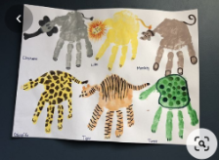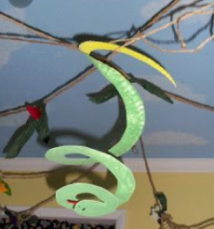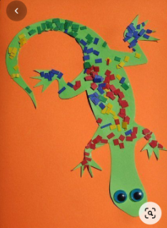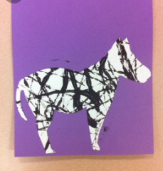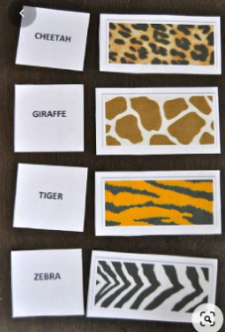
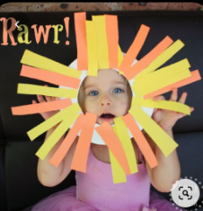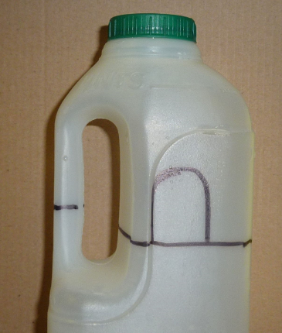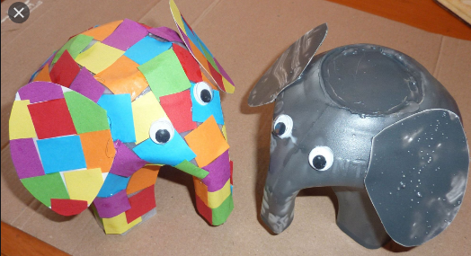
Jungle Hunt
Sing 'Down in the Jungle' and practice the different movements for each animal. Big jumps for the monkey, stomping feet for the elephant, and slithering on tummies for the snake.
https://www.youtube.com/watch?v=25_u1GzruQM
Hide the pictures of the animals (or drawings if you do not have a printer) around your house and garden. Listen out for the noises each animal makes. When an animal has been found, can you move like that animal, such as slithering, shuffling, rolling, crawling, walking, running, jumping, skipping, sliding and hopping to find the next animal?

What am I?
Use the PowerPoint attached to guess the jungle animals from the clues.
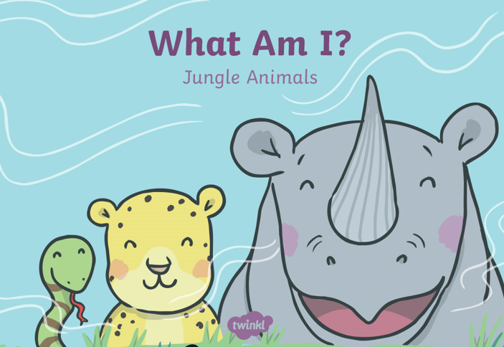

Maths
https://whiterosemaths.com/homelearning/early-years/
Go to the home learning section for Early Years on the ‘White Rose’ website and here you will find the section for this week.
Each day begins with a 5-minute video to watch. There are different activity ideas which can all be done without the book. The video starts with the ‘days of the week’ song which the children should know!

Jungle shapes game
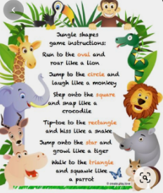

Singing
Down in the Jungle song https://www.youtube.com/watch?v=25_u1GzruQM

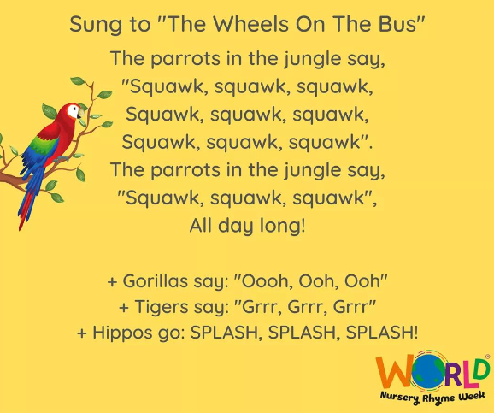
Exercise time
- Down in the Jungle song and dance
https://www.youtube.com/watch?v=-zxcGKIMcOs
- Jamie’s Jungle Brain Break
https://www.youtube.com/watch?v=dKa2LHYcln4
- Try this Jungle HIIT session
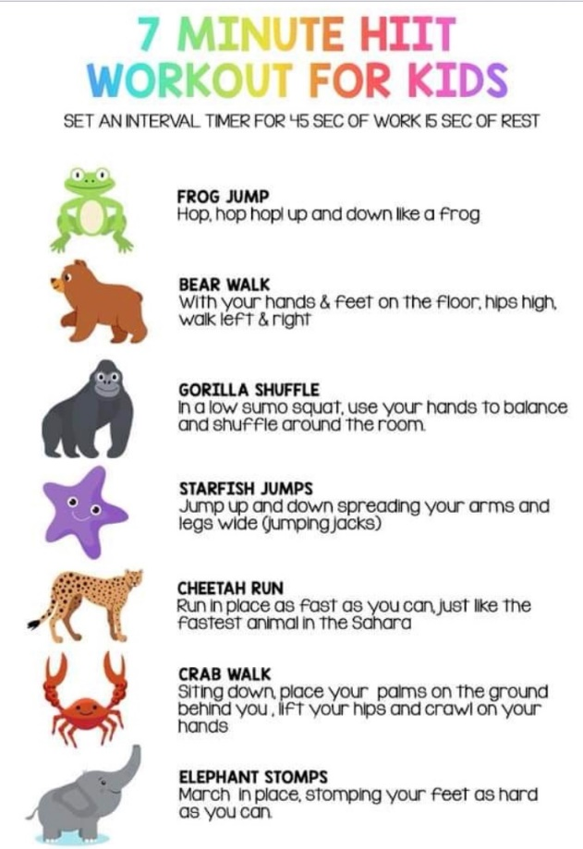

Phonics/ reading

- Get Epic- We have given all our children access to a free online library called Epic. https://www.getepic.com/students It is an American site so there may be a few different spellings to be aware of. However, there are many books that you can read online and the site looks like it should be very useful. I have attached more Login info but your class code is: jee4285

- Oxford owl- Visit the oxford owl website and click on the 'My class login' button.
Enter these details:
Username: crawcrooknursery
Password: Emmaville
- Letters and Sounds website phase 1 Listening games:
http://www.letters-and-sounds.com/phase-1.html

